**PROJECT 2**

**Day 4 | 22nd August 2020**

Submitted By :- Satyaprakash Das

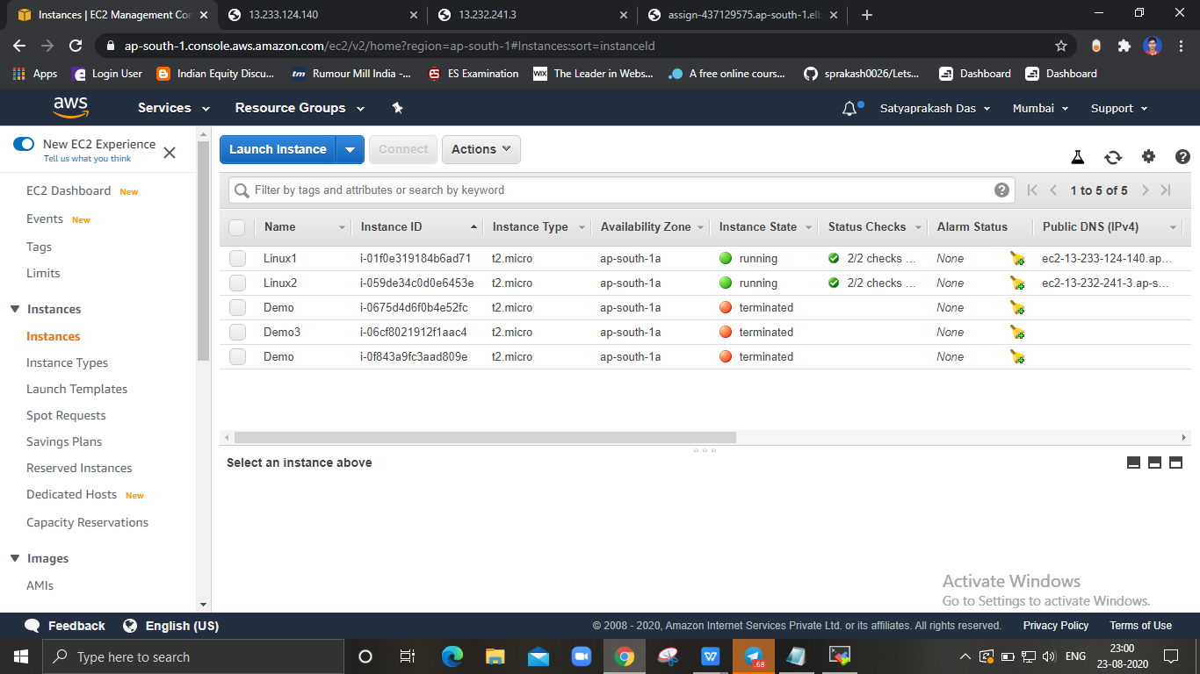

**(BOTH THE INSTANCES WHILE RUNNING)**

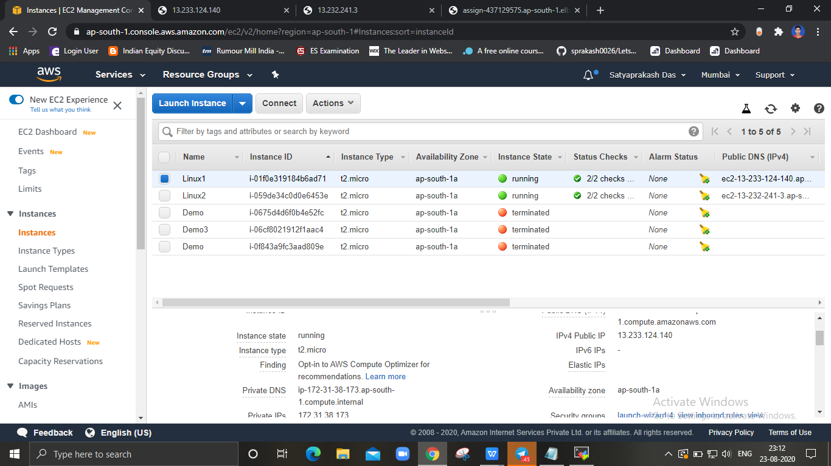

**(LINUX 1 WITH IP ADDRESS)**

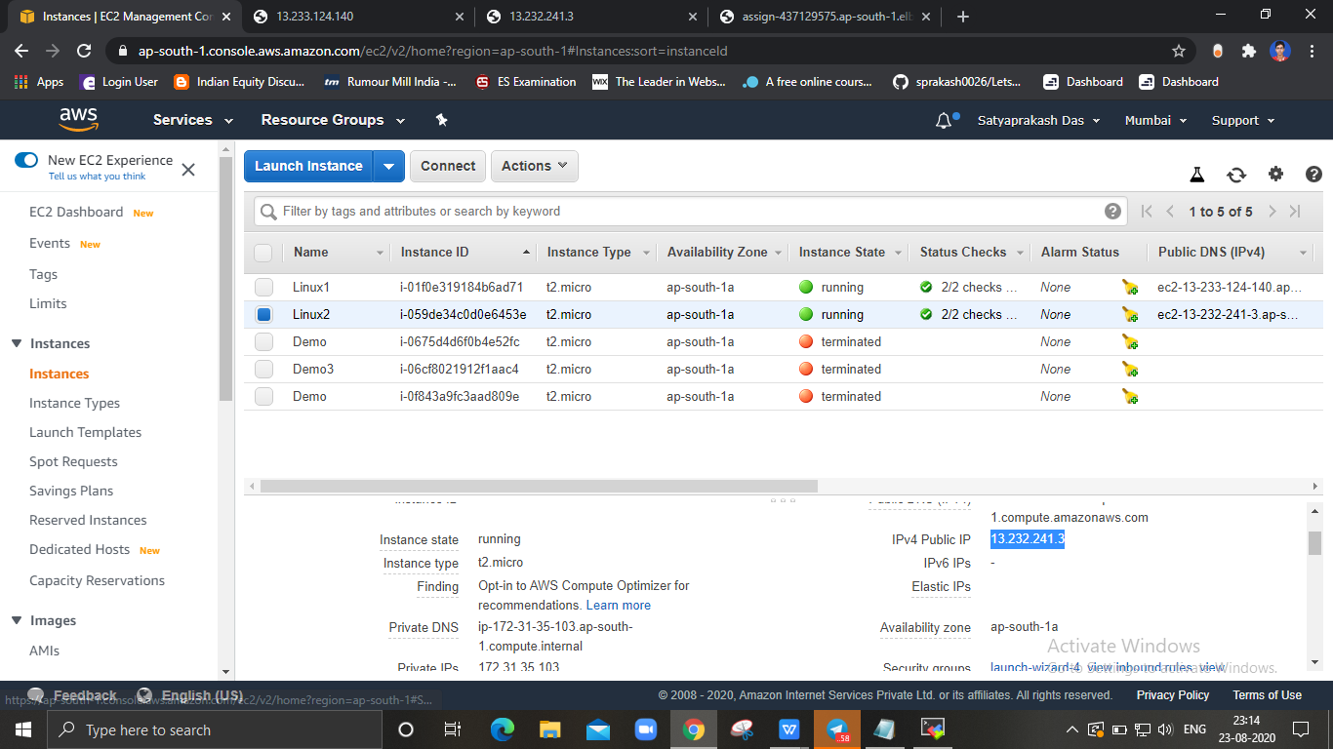

**(LINUX 2 WITH PUBLIC IP )**

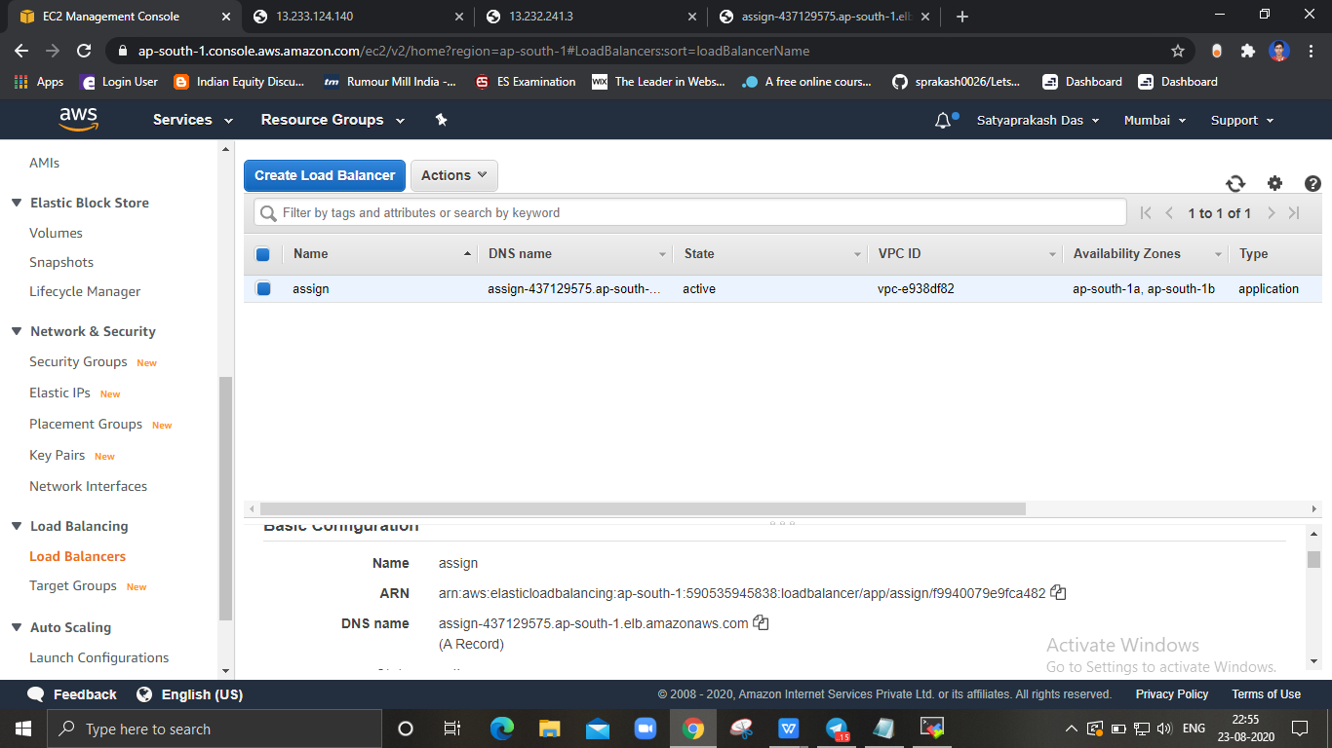

**(LOAD BALANCER WHILE ACTIVE )**

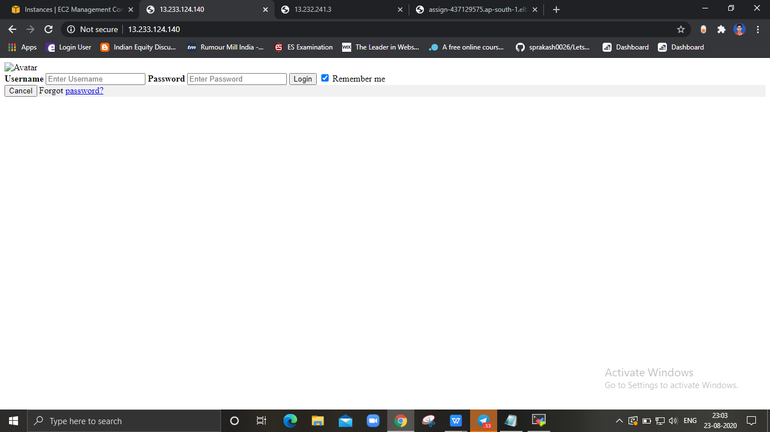

**( LINUX 1 HOSTED SUCCESFULLY )**

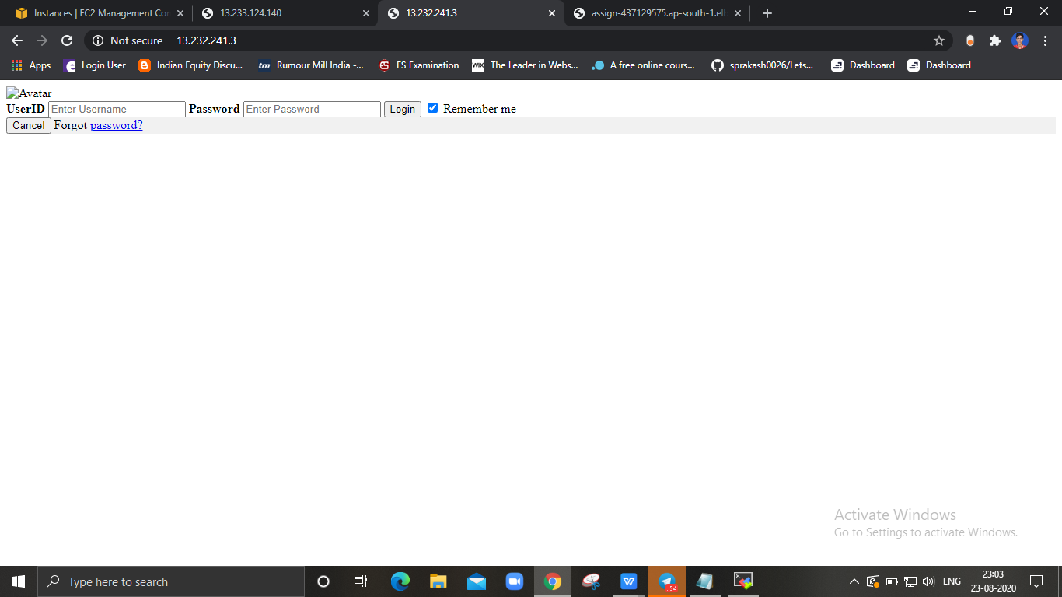

**( LINUX 2 HOSTED SUCCESFULLY )**

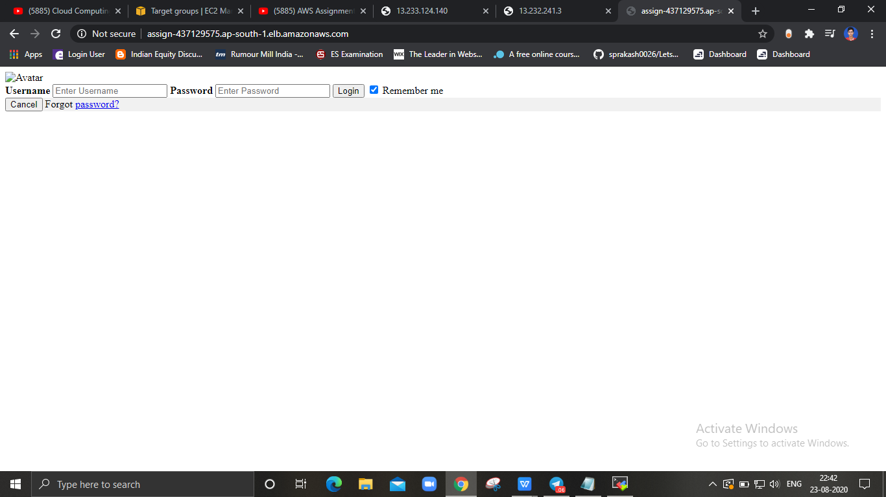

**(DNS RESPONDING TO LINUX 1 )**

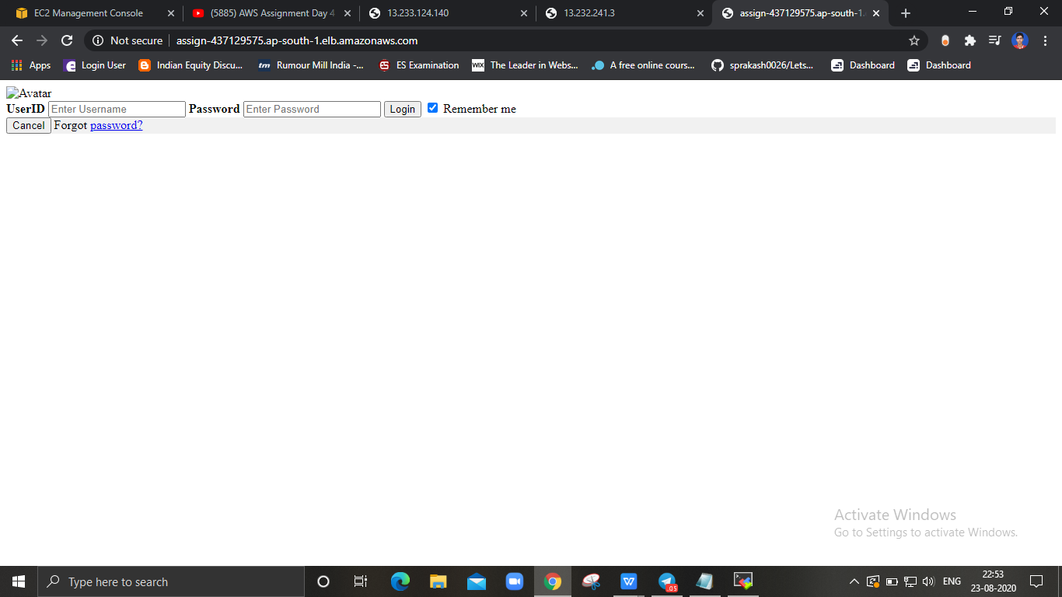

**( DNS RESPONDING TO LINUX 2 )**